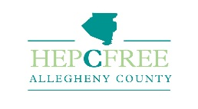

A HCV Elimination Plan for Allegheny County

The Allegheny County Health Department and the Community Liver Alliance has joined forces to lead a group of stakeholders to work on a HCV Elimination Plan for Allegheny County, Pennsylvania. The primary purpose of the taskforce is to ensure that Allegheny County residents, especially those at high risk of infection, have access to testing, care, and treatment. Through our investigation into other like initiatives, we have come to realize that there are very few states that have a HCV elimination plan in place.

Vision
Hep C Free Allegheny envisions a county where coordinated, multi-sector efforts result in the prevention of new HCV infections, the timely identification of those who ae living with chronic HCV infection and their subsequent linkage to curative therapy and the eventual elimination of HCV-related health inequities.

Mission
To support all Allegheny County residents living with and at risk for hepatis C to maximize their health and wellness. We achieve this through coordinated, multi-sector efforts to expand prevention, education, tesing an timely access to care and treatmet for all who are infected.

We have created four Working Groups. Each Working Group has a set of Co-Chairs and members.

Workgroups
- Surveillance and Research
- Testing and Linkage to Care
- Treatment Expansion
- Education, Prevention and Advocacy

