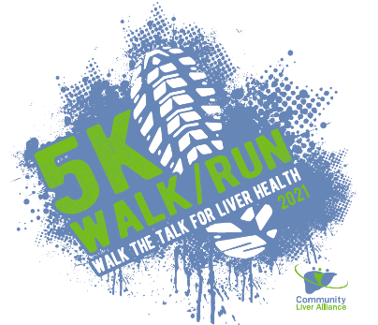

Registration List for the 5K Walk/Run
Saturday, September 18, 2021

Name | Email | Address | Date of Birth | Gender | Phone | T-shirt Size

Or Register Online at:
https://p2p.onecause.com/clawalk
TEAM NAME: _____________________________________________

