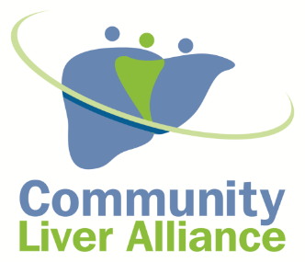
Community Liver Alliance
100 W. Station Square Drive, Suite 1945
Pittsburgh, PA 15219
412.501.3CLA
www.communityliveralliance.org

Dear CLA Partner;
The Community Liver Alliance invites you to participate as an Exhibitor at NASH Update Program on August 21, 2019 from 5:00 p.m. – 8:30 p.m. at Connected Health in Wexford, PA.

We are requesting $2000 exhibit fee to support the program. The fee includes an exhibit table/chairs, 4 program registration and a listing in the program. Please use the attached form to submit your payment.

The goal of this program is to address Non-Alcoholic Liver Disease and associated conditions and to educate about screening recommendations, current treatment options, drug trials, drug interactions, pediatric diseases, nutrition and physical activity. We will also have a Liver Transplantation Update.

We are also planning Interactive Sessions to include a healthy cooking demonstration, physical activity demonstration and a Patient and Provider Panel Discussion.

Our speakers represent the experts from UPMC, Allegheny Health Network, and other community partners to bring up to date information.

5:00 p.m.
Registration and Dinner
5:30 p.m.
You Really Are What You Eat: A Healthy Cooking Demonstration and Lecture
How to Improve Your Liver Health Through Nutrition and Weight Management

Karen Jerome-Zapadka, MD
Valley Gastroenterology Associates
&
Chef Paul Morrison
Sysco Pittsburgh
6:15 p.m.
Let’s Get Moving!
How to Incorporate Physical Activity into Your Daily Life

Alex Arnold, Director of Fitness
Connected Health
6:30 p.m.
Medications and Liver Disease
Betty Rich, RPh and Owner
Connected Health

6:50 p.m.
Nash Evaluation and Treatment

What is new in the Diagnosis and Treatment of NASH
Jaideep Behari, MD
UPMC Center for Liver Diseases

Updates in NASH Cirrhosis
Christina Strahotin, MD
Allegheny Health Network Center for Digestive Health and Nutrition

7:40 p.m.
Pediatric Fatty Liver Disease
Robert Squires, MD
Children’s Hospital of Pittsburgh
8:05 p.m.
Living Liver Donor Transplantation
Swaytha Ganesh, MD
UPMC Thomas E. Starzl Transplantation Institute
8:30 p.m.
Patient and Caregiver Panel Discussion

Your generous support allows the Community Liver Alliance and its community partners to expand programs and efforts to reach greater numbers of the population we serve. If you have any additional questions, please contact Suzanna Masartis at 412-400-9343 or via email at Suzanna@communityliveralliance.org

Sincerely,

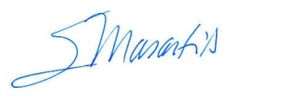

Suzanna Masartis

Executive Director

Community Liver Alliance
100 W. Station Square Drive, Suite 1945
Pittsburgh, PA 15219
412.501.3CLA
www.communityliveralliance.org
Exhibit Payment Form
NASH Update
August 21, 2019
5:00 p.m. – 8:30 p.m.

- Yes, I would like to participate as an exhibitor
Fee: $2000.00 Name______________________________________________________________________
Company Name______________________________________________________________
Address_____________________________________________________________________
City_________________________ ______________State_____________ Zip____________
Phone__________________________________ Email Address:________________________

Please make checks payable to the Community Liver Alliance 100 W. Station Square Drive, Ste. 1945 Pittsburgh, PA 15219

Credit Card Payment
I ____________________________ authorize Community Liver Alliance to charge my credit card
(full name)
account indicated below for _____________ on or after_______________________. This payment is for
(amount) (date)
____________________________________________.
(description of goods/services)

Billing Address____________________________ Phone#________________________
City, State, Zip ____________________________ Email ________________________
Account Type: Visa MasterCard AMEX Discover
Cardholder Name _______________________________________________
Account Number _______________________________________________
Expiration Date __________________ Billing Zip Code _______________
CVV2 (3 digit number on back of Visa/MC, 4 digits on front of AMEX) _______
SIGNATURE DATE

I authorize the above named business to charge the credit card indicated in this authorization form according to the terms outlined above. This payment authorization is for the goods/services described above, for the amount indicated above only, and is valid for one time use only. I certify that I am an authorized user of this credit card and that I will not dispute the payment with my credit card company; so long as the transaction corresponds to the terms indicated in this form.

